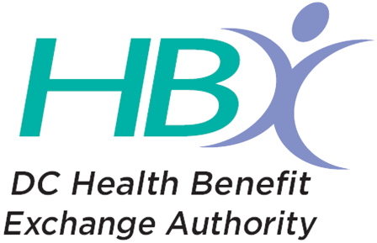
ACA ADVISORY WORKING GROUP MEETING
AGENDA

Date: Friday, September 22, 2017
Time: 10:00 AM
Location: 1225 “Eye” Street NW, 4th Floor, Board Conference Room or by Conference Call
Call- in Number: 1-650-479-3208; access code 739 921 858

NOTE: Given the religious holiday and the potential for Congressional action on ACA repeal efforts prior to September 30th, no votes will be taken at this meeting. Votes will be delayed to a future meeting of the ACA Working Group.

Welcome, Opening Remarks and Roll Call
Leighton Ku, Chair
Discussion Items

Affordability Discussion Continued – Purvee Kempf & Debbie Curtis, HBX Staff

Local reinsurance –Review of preliminary analysis from Oliver Wyman Actuaries and ongoing discussion

APTC and or CSR add on (in form of additional tax credits or subsidies)

Closing Remarks and Adjourn

Leighton Ku, Chair

