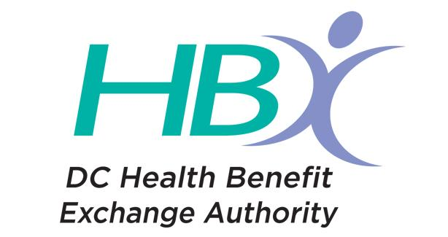
District of Columbia Health Benefit Exchange
Out of Pocket Cost Calculator
Financial and Board Submission Summary

Background: On August 13, 2013, the Board approved work by Consumers’ CHECKBOOK/ Center for the Study of Service (CSS). The Board’s approval included a doctor directory. It was also for development of a cost calculator in two parts: an initial “generic” cost calculator to be followed by deployment of a “full cost calculator” that would allow consumers “to compare options with more information,” i.e., to conduct anonymous plan shopping with an out-of-pocket cost calculator. The initial generic cost calculator was deployed in advance of the first open enrollment period (October 1, 2013). Deployment of the full cost calculator was delayed due to technical challenges. Those challenges have now been overcome, and, this summer, CSS undertook development work to deploy the full cost calculator. The full cost calculator is on track to be available for plan year 2016 for both individual market and SHOP customers when open enrollment begins on November 1. We expect to launch the individual market tool in beta form in September.

The contract with CSS expires on September 30, 2015. We seek approval from the Board to exercise Option Year 1 for FY 2016. We also seek clarification that the Board has approved the exercise of two additional option years for maintenance of the cost calculators and doctor directory. The option year costs include maintenance, which includes updating the
algorithm to reflect the current plan year benefits and rates, as well as on going doctor directory updates.

Contract and Price: Contract with CSS includes three option years

Option Year 1 (10/1/15 through 9/30/16): $522,711
Option year 2 (10/1/16 through 9/30/17): $513,887
Option year 3 (10/1/17 through 9.30/17): $514,300

The contract is not cost allocated. Because this is a recurring expense, we seek Board approval to exercise each of these three options at the appropriate time.

